OVERALL PROGRAMME EVALUATION REPORT
Social Entrepreneurship Development Program (SEDP)- Advance Uganda (2nd March 2026 - 6th March 2026)
No. of Respondents: 22
No. of Participants: 244
Response Rate: 9%
--------------------------------------------------

Faculty Reports

Dr. Cathy Mbidde - Establishing Social Impact
Evaluation Parameter | (%) Individual Score | (%) Programme Average
Punctuality (Commencement and Completion of Sessions) | 97 | 91
How well do you understand the core concepts presented? | 96 | 92
Rate your confidence in applying the new skills learnt | 88 | 87
Degree of Faculty preparedness for the sessions | 98 | 97
Content and methodology of the program | 99 | 95
Quality of class and group discussions | 96 | 89
The information presented in the course is relevant to my work (ministry) | 98 | 97
Average scores | 96 | 93

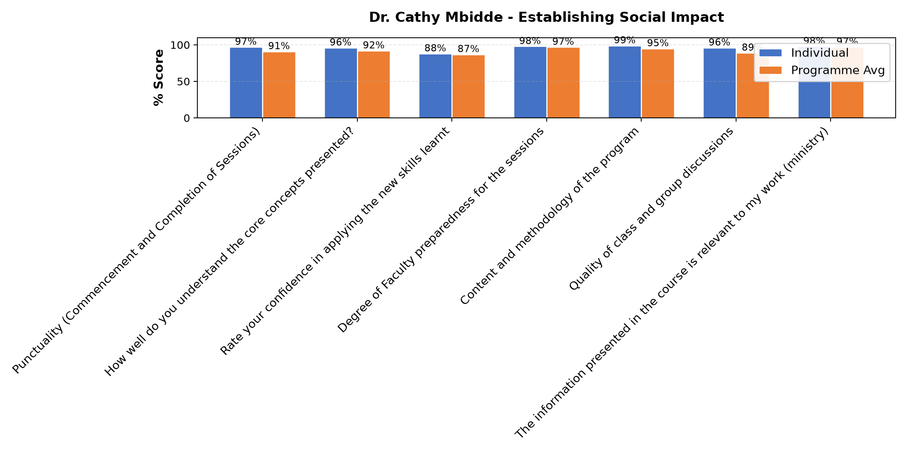

Comments & Feedback
- • She talked alot about social impact it will take time.
- • Language of the People where we are starting the enterprise
- • Good time needed to work with the neighboring community.
- • I will try to put everything into practice though the barriers are there like lack of money,time, follow up.but I will try.
- • funds to expand my social enterprise
- • Finance
- • Being able to truck all the students so that I can measure well the social impact
- • Failing to get time
- • There will be no barriers preventing me from applying what I have learnt.

Dr. Tom Buringuriza - Funding Sources
Evaluation Parameter | (%) Individual Score | (%) Programme Average
Punctuality (Commencement and Completion of Sessions) | 98 | 91
How well do you understand the core concepts presented? | 90 | 92
Rate your confidence in applying the new skills learnt | 88 | 87
Degree of Faculty preparedness for the sessions | 98 | 97
Content and methodology of the program | 95 | 95
Quality of class and group discussions | 84 | 89
The information presented in the course is relevant to my work (ministry) | 96 | 97
Average scores | 93 | 93

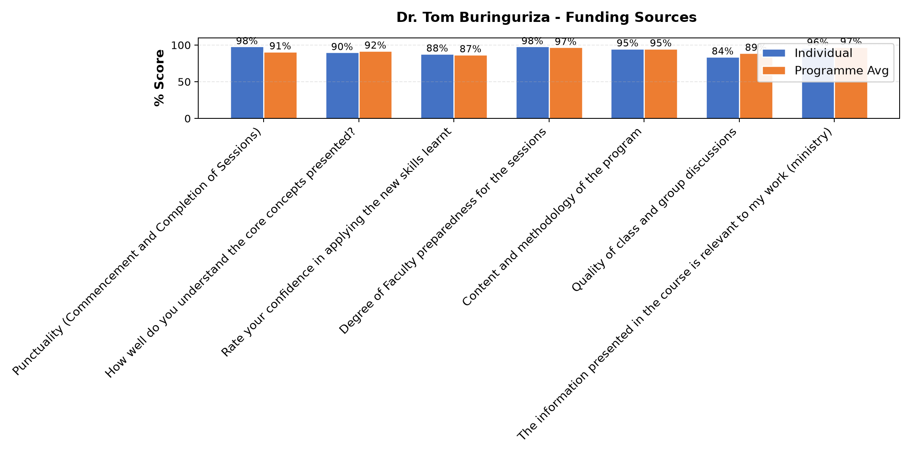

Comments & Feedback
- • Finance
- • Shortage of enough funds
- • Inadequate infrastructure, personal mindset or motivation issues, and external constraints such as policies or financial limitations.
- • Lack of skills. One day is not enough if you have never learnt accountants
- • Commitment $ long distance banking very little money collected.
- • A lot is still needed to learn
- • Finance
- • I personally do not have any barrier in applying what i have learnt; I have to put it into practice immediately and always.

Dr. Tom Buringuriza - Governance and Succession Planning
Evaluation Parameter | (%) Individual Score | (%) Programme Average
Punctuality (Commencement and Completion of Sessions) | 100 | 91
How well do you understand the core concepts presented? | 91 | 92
Rate your confidence in applying the new skills learnt | 89 | 87
Degree of Faculty preparedness for the sessions | 100 | 97
Content and methodology of the program | 100 | 95
Quality of class and group discussions | 93 | 89
The information presented in the course is relevant to my work (ministry) | 100 | 97
Average scores | 96 | 93

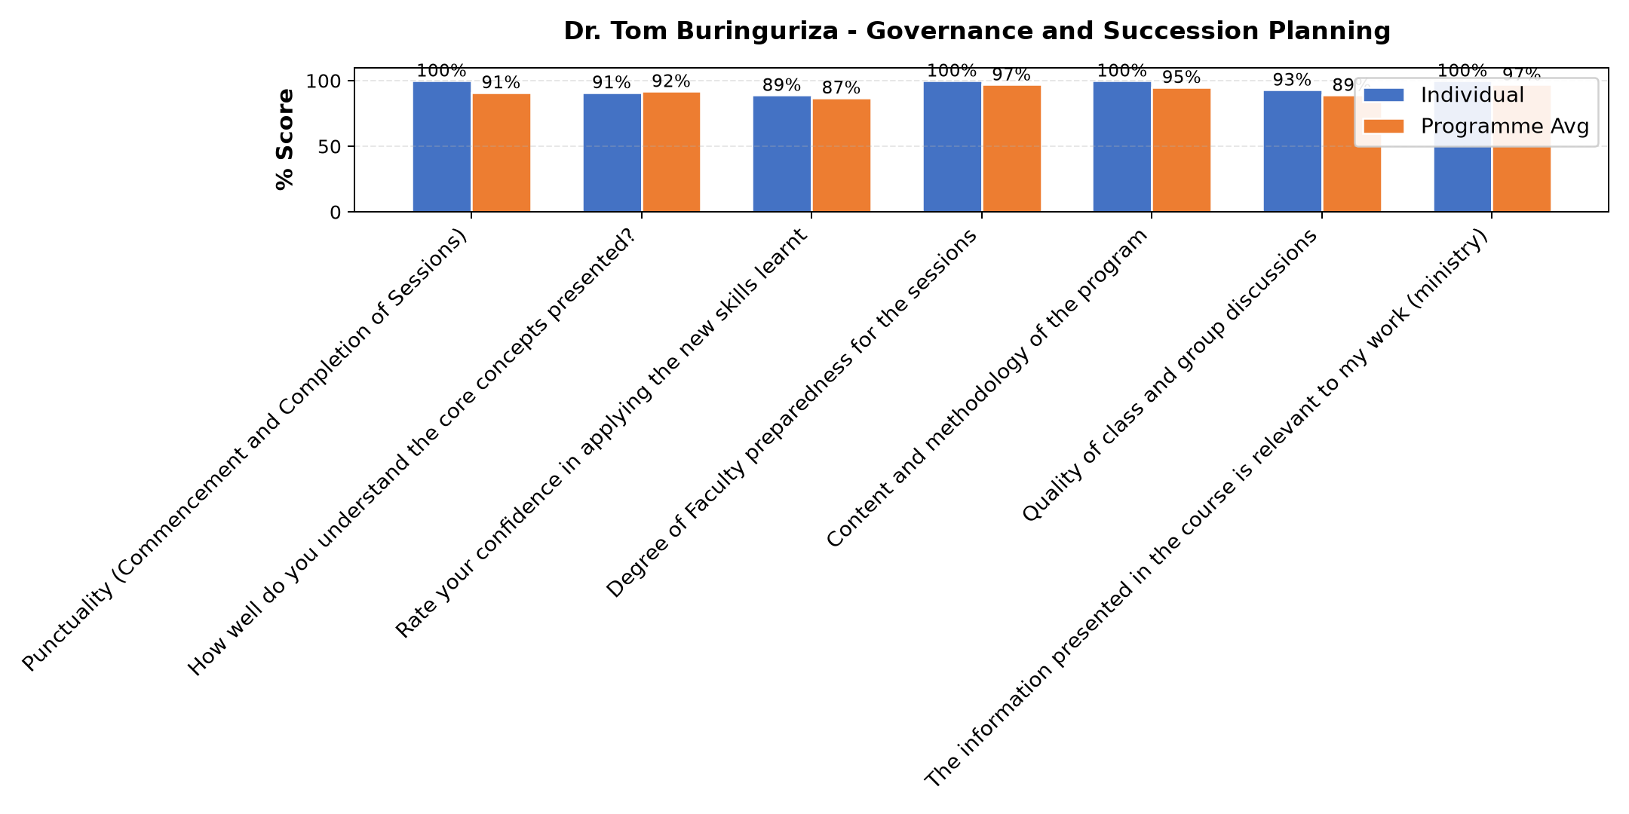

Comments & Feedback
- • Deeper knowledge of the importance of some taxes
- • Good presentations
- • The lecturer took us from a lay man and a beginner perspective that made us got the concept of Governance and succession planning very well.

Dr. Evelyn Kahiigi - IT and Technology
Evaluation Parameter | (%) Individual Score | (%) Programme Average
Punctuality (Commencement and Completion of Sessions) | 78 | 91
How well do you understand the core concepts presented? | 85 | 92
Rate your confidence in applying the new skills learnt | 77 | 87
Degree of Faculty preparedness for the sessions | 87 | 97
Content and methodology of the program | 84 | 95
Quality of class and group discussions | 81 | 89
The information presented in the course is relevant to my work (ministry) | 93 | 97
Average scores | 84 | 93

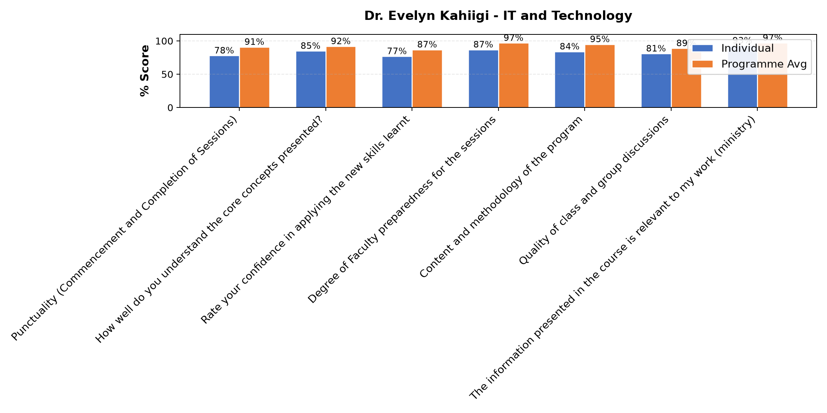

Comments & Feedback
- • Need to Learn more on IT
- • The content presented was good but not practically done.Maily theory
- • Lack of data because most of the online things needs data and it's not regularly provided in some communities like mine
- • Not being so practical I computer programs
- • The class was more of theory we needed more of practice
- • Limited know how
- • network problem, Internet data
- • Slow network
- • Lack of some tools like the computer
- • Data
- • No barriers
- • The most like barriers can be when I may run short of data since it requires data so as to connected on line. otherwise it is doable.
- • Am going to try to apply them
- • Limited support from superiors, colleagues, or management can discourage implementation. And also, time constraints—being too busy or overloaded with work—can prevent me from practicing new knowledge. Another barrier is lack of follow-up and supervision. After training, there is no guidance.

Dison Bosco Okumu - Operations and Efficiency
Evaluation Parameter | (%) Individual Score | (%) Programme Average
Punctuality (Commencement and Completion of Sessions) | 84 | 91
How well do you understand the core concepts presented? | 97 | 92
Rate your confidence in applying the new skills learnt | 91 | 87
Degree of Faculty preparedness for the sessions | 100 | 97
Content and methodology of the program | 97 | 95
Quality of class and group discussions | 91 | 89
The information presented in the course is relevant to my work (ministry) | 96 | 97
Average scores | 94 | 93

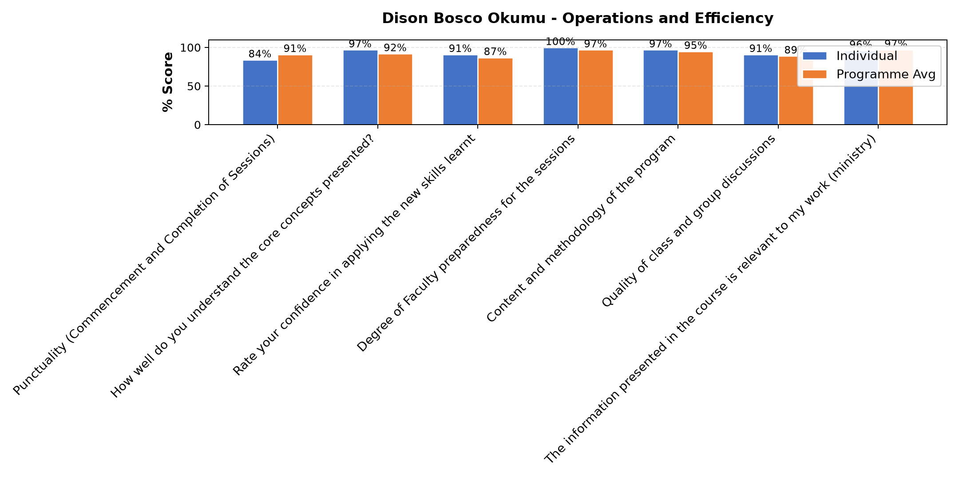

Comments & Feedback
- • Theft, inadequate resources or finance
- • Maybe lack of follow-up might prevent me from applying what I learned. Otherwise i feel strong to put into practice what I received.
- • Negative attitude
- • No any barrier at all.
- • Failing to understand people's mindset
- • Time and resources
- • There's no any barriers that can prevent me from applying what I learned because the facilitator was down on earth. And he is competent he knows what he is talking about. In fact let him always facilitate every group that comes to learn.
- • Nothing
- • So far nothing and I will try my best to implement the knowledge I have received
- • Mindset
- • Nothing
- • I feel there will be no barriers in applying what I have learnt in my Social Enterprises.
- • Not being on the ground
- • Lack of enough resources

Department Reports

Accommodation Venue
Evaluation Parameter | (%) Score
Comfort and cleanliness of the accomodation | 98
Quality of meals and dining services provided | 84
Overall satisfaction with the accomodation experience | 87
Average score | 90

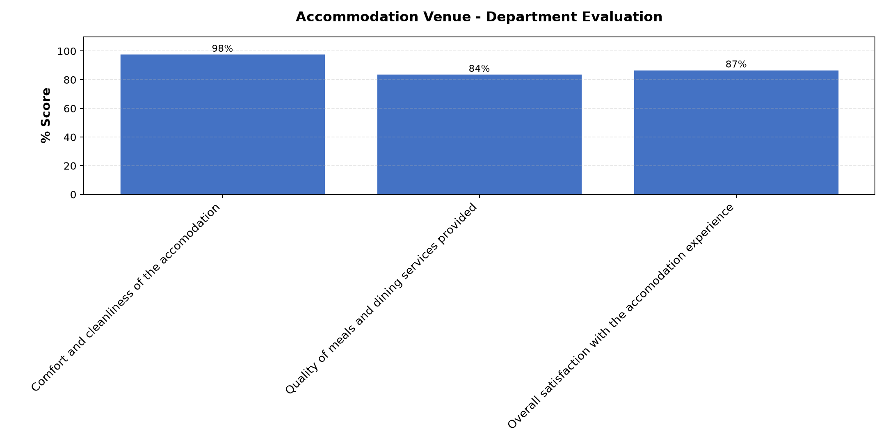

Comments & Feedback
- • A vote of thanks to the entire staff of Strathmore university, our regional coordinator facilitators and support staff
- • It was wonderful to meet again
- • A vote of thanks to all the facilitators and organizers and also to.all.those who have sponsored us.we.have benefitted alot.
- • A word of thank you for everything
- • Good
- • Very good accommodation.
- • At least provision of 2 toilet papers

Are there any other comments and/or suggestions that you may want to add?

Comments & Feedback
- • Whoever has supported us in this program we appreciate
- • To continue training other sisters
- • Was surprised to see a sister being stopped from serving milk that she was serving alot.

Day 1 Further Comments

Comments & Feedback
- • Special thanks to Dr. Evelyn
- • So much appreciated
- • No
- • IT and Technology required more practically
- • More practice and group discussions are necessary
- • Many thanks for the knowledge received
- • I need to learn more of ICT and yesterday's session was so relevant to me and very helpful
- • The class session was not to my expectations and the computer was not well utilized in the lessons
- • Looking forward for more practice
- • Very appreciative to Dr.Everlyn for well presented topic, Thank you for all who has put the mind, heart, knowledge, funds so that the Sisters can pursue this. Your reward is in heaven.
- • Good presentation
- • It has been to learn about AI and at least we have been give enough time to rest on.
- • If possible let everyone day get time to rest
- • It need more explanation and practicing
- • A practical topic on how to use AI will be very useful
- • I personally experienced some draw back in catching up with during the session because the net work was very slow such that i got a bit .
- • Thank you for explaining complex IT technical concepts. I really appreciate the hands-on, practical, and real-world examples you shared and hope to apply some of tools in my daily life...thanks to Strathmore University for initiativing such a program...
- • Applying what we learn is not easy. But I will try to put it into practice with the help of God. Otherwise, thank you so much. God bless the work of your hands.

Day 2 Further Comments

Comments & Feedback
- • So grateful about the operational efficiency
- • Dr. Dison Okumu was a good choice made to Facilitate this topic Operational Efficiency, He is an experienced person in this field and shared with real experience
- • We need to have like two more weeks to get more of what you are preparing for us. They are good things and enriching, but time was not good for us all, according to my observation. Otherwise, thank you so much; the session was so wonderful and lively. God bless you.
- • He was down to earth and loud enough.The content given was important and eye opening
- • I have never seen or attended such an excellent lesson in the area of Operations and efficiency. Mr Okumu brought us down to earth. To understand and live in our world today and now. God bless him.
- • It has been a very fruitful presentation and I ha e learnt alot.
- • He explains very well he uses the real examples that everyone can understand. He is just an excellent facilitator.
- • Well delivered
- • May the Lord bless Mr.Dison Okumu with a long life knowledge and wisdom in order to guide more people. Thanks 🙏🙏
- • It needed abit more times
- • We need to consult him in future for our enterprise to cont inue to grow. .
- • Excellent presentation
- • I would to give further comment that the presenter was so much down to earth with very language and as he was presenting I was immediately in connection with my Enterprises, which very interesting.
- • A big thank you to the Facilitator and the organizing team
- • So much appreciated
- • Very interesting and enriching topic

Day 3 Further Comments

Comments & Feedback
- • So grateful about the funding tips
- • THE SESSION WAS GOOD AND ENRICHING, BUT IT NEEDS MORE TIME. THANK YOU SO MUCH, DR.
- • The facilitator was good
- • Good presentations from the facilitator
- • I really appreciate for the nice presentation.
- • Thanks a million
- • Very experienced proffessor.
- • It has been good. It will help me to impact the community
- • Humble Request that Dr. Tom be assign by Strathmore University if possible to continue mentoring the SBVP Allumni in this Funding Sources area
- • Thanks for the presentation
- • The presentation was so inspiring and is going to help me on looking for funds for our other projects too
- • We dsð3
- • Excellent
- • The content is very enriching and helpful. thank you very much Dr. Tom.

Day 5 Further Comments

Comments & Feedback
- • Smart and clear with good and relevant examples.
- • Very educative
- • Thanks for the enlightenment About governance and succession planning,plus registration of our enterprises plus the needs that come along.
- • It has been a good presentation which has helped.me to.know the importance of various compliance of taxes.
- • Dr. Tom is very competent, knowledgeable about the discipline.
- • Very well explained topic

Guest-Speaker Session
Evaluation Parameter | (%) Score
Speaker's Quality of discussions | 96
Speaker's degree of preparation for the session | 96
Information presented in the course was relevant to my work | 98
Presentation was well structured | 93
Delivery methodology was appropriate | 96
Average score | 96

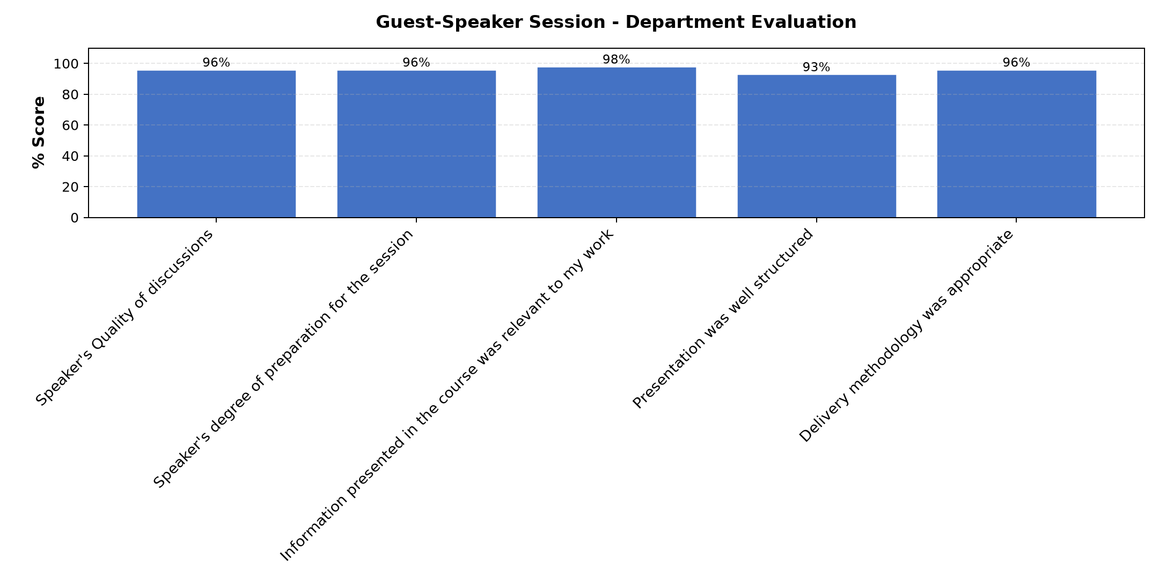

Comments & Feedback
- • Good information but time given was not enough compared to what she had share
- • Enriching
- • The presentation was very good and relevant to our social enterprise
- • Nice presentations
- • M/s Philo is a very well informed person on legal issues. she as widen my understanding on the importance of following legalprocedures.
- • More time for tthis presentation

Overall Evaluation
Evaluation Parameter | (%) Score
Overall program evaluation | 96
Average score | 96

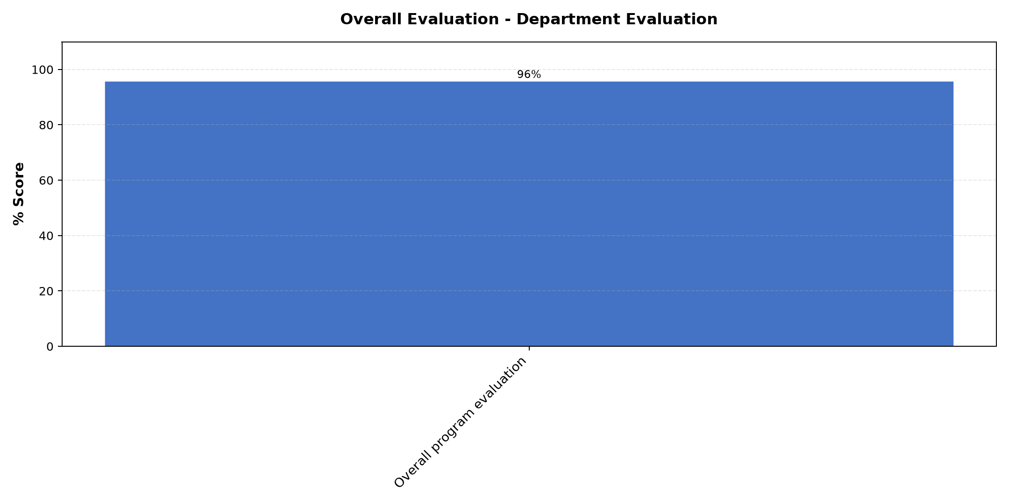

Comments & Feedback
- • All the topics were very relevant in improving our social enterprise
- • Operational efficiency
- • Taxation
- • Registration
- • All the areas presented very important and necessary for Social enterprises.
- • Registration of our enterprises,governance essentials,types of businesses in uganda and clarity on URA and NSSF issues
- • Establishing social impact
- • All of them were relevant.
- • Key aspects and procedures to follow when starting an enterprise.

Program Manager (Venance Mwakangale)
Evaluation Parameter | (%) Score
Punctuality in sending materials and programme information | 98
Communication skills(verbal and written) | 91
Response to programme enquiries via email, whatsapp and calls | 98
Accessibility and willingness to support when needed | 89
Quality of service / professionalism | 91
Average score | 93

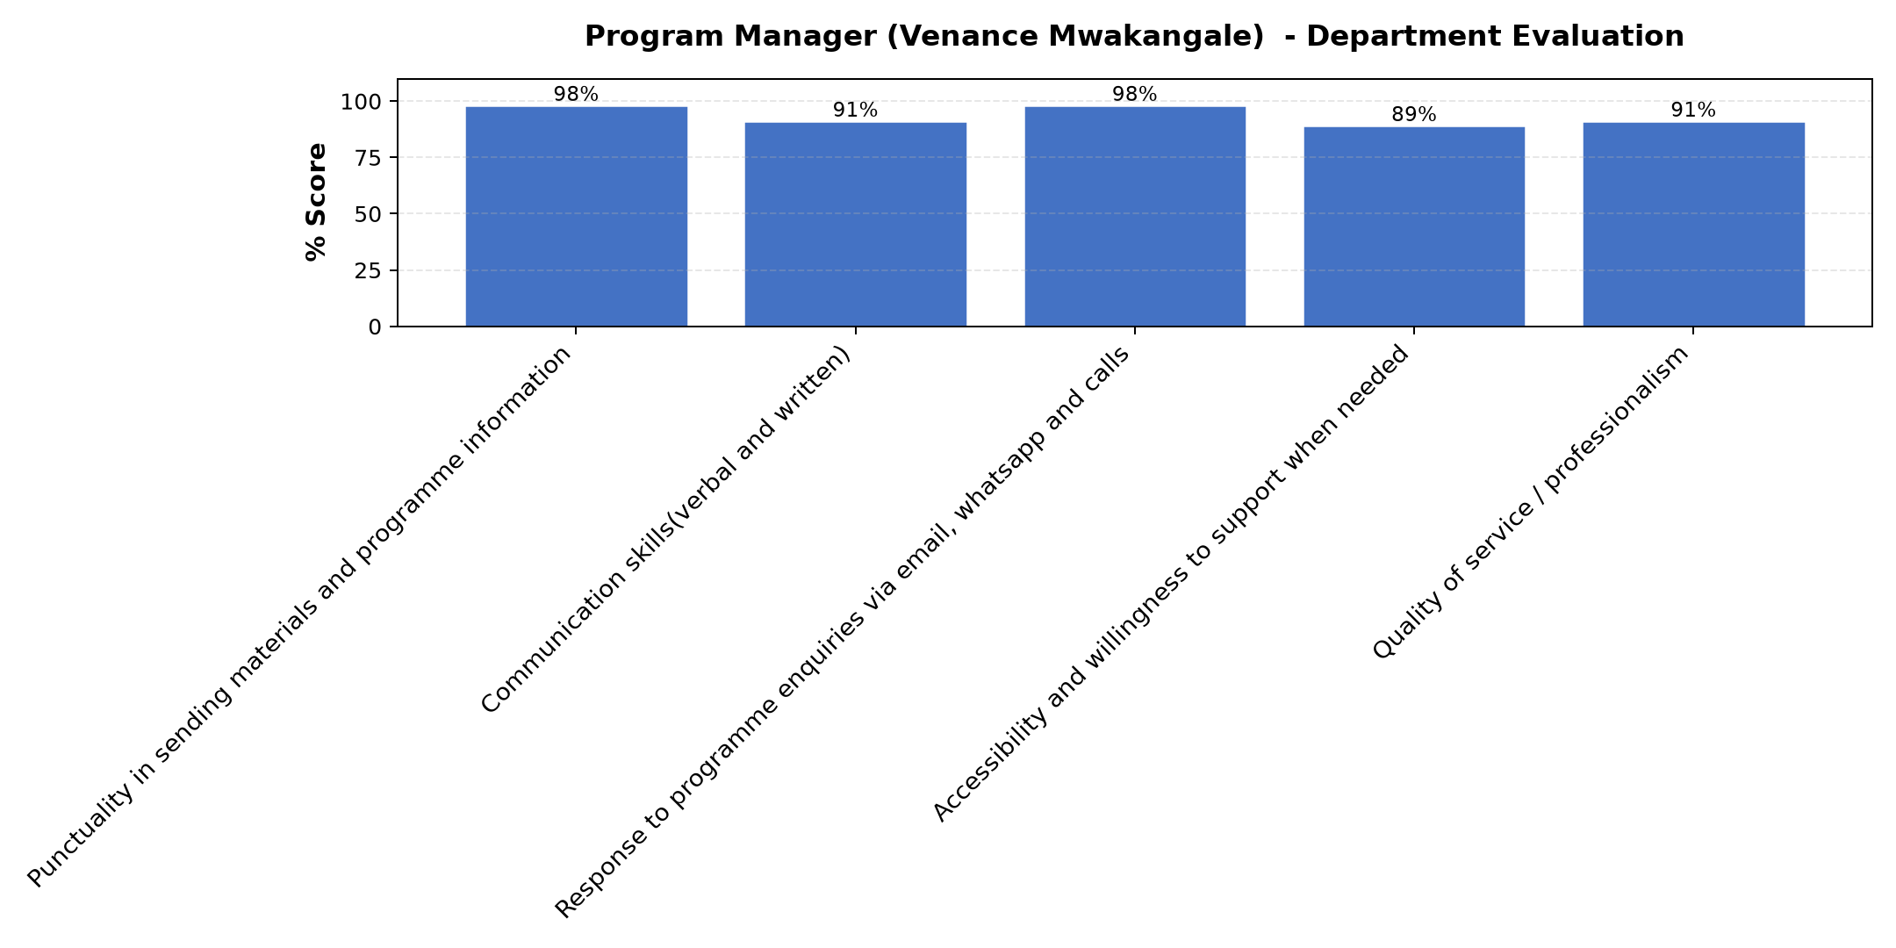

Comments & Feedback
- • He coordinates well all the members, leaving no one behind and good in giving feed back
- • Continue with the Spirit
- • The program is very educative and relevant to our missions
- • Venance is such a well trained and balanced person who has passion for his work.
- • He was not present but communication was done effectively

Social Enterprise Visit
Evaluation Parameter | (%) Score
Quality of the pre-visit planning & information shared.1 | 99
Quality of the plant visit | 99
Quality of content discussed.1 | 92
Overall company visit evaluation.1 | 97
Average score | 97

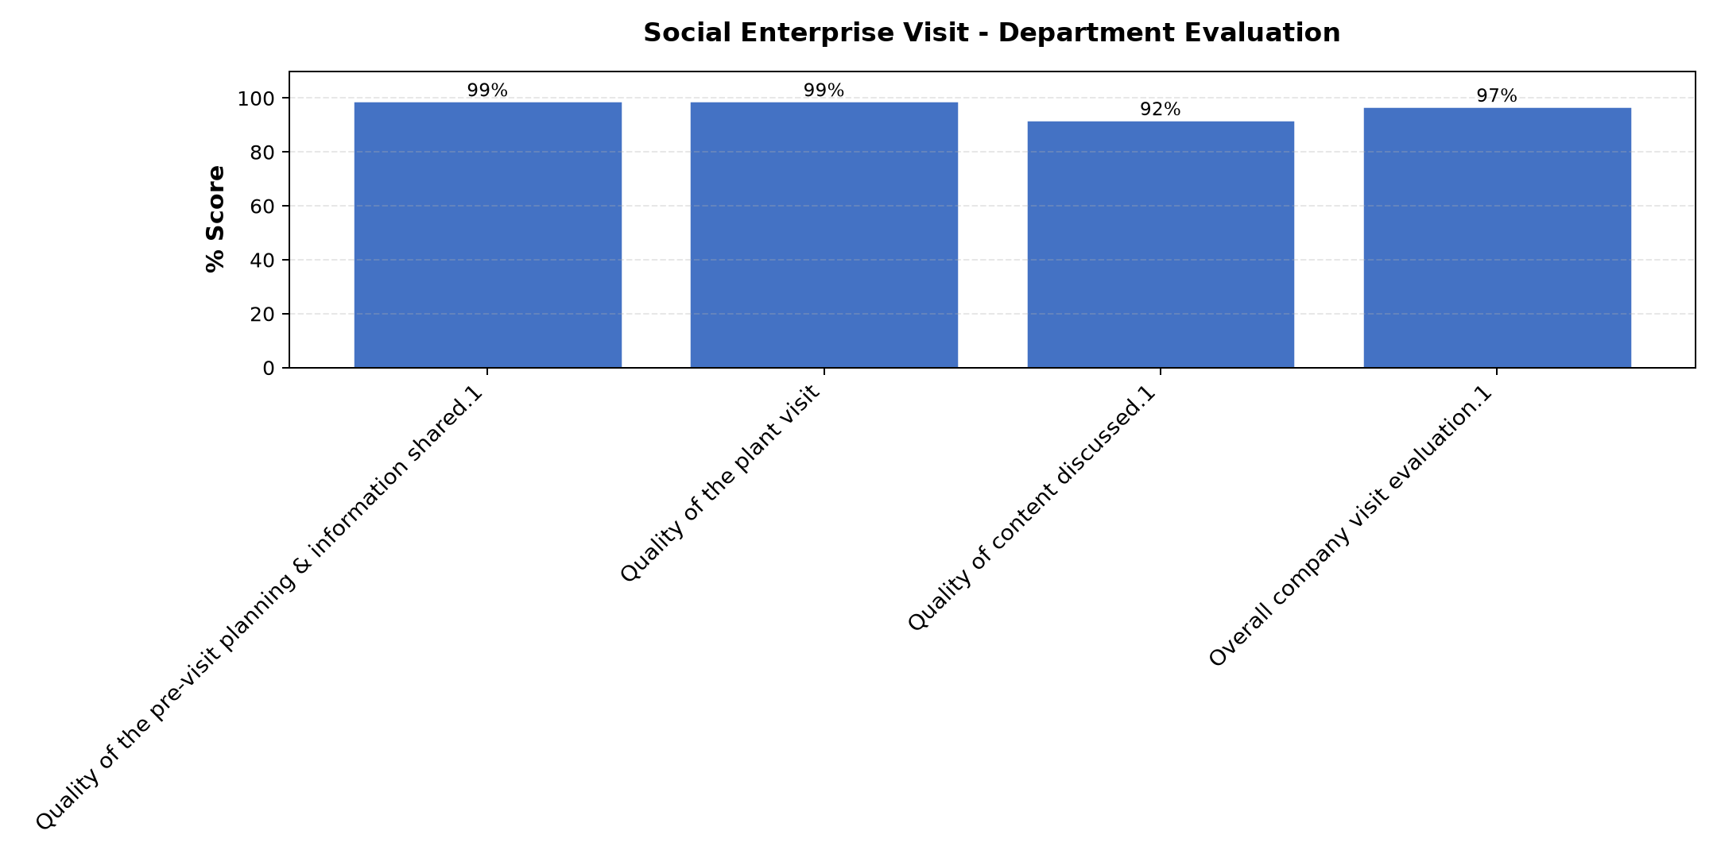

Comments & Feedback
- • Special thanks to Dr. Cathy for everything delivered today that challenged me to be more creative, innovation and more impactful in society...
- • It's wonderful to see innovation in African people. That is how the west has excelled in development. One day we shall be there too.
- • A word of thank you
- • We need to be enlightened more in our context of social Enterprises to be innovative and bring an impact
- • All the information discussed and shared was good and Challenging.we're so much grateful to Dr Cathy and the team.
- • Thank you so much 🙏🙏God bless the work of your hands 🙏🙏
- • I love the clarity that proffessor gived and the group involvement.She has always been the best presenter.
- • Dr. Cathy should give us more insight how to be more innovated.
- • The facilitator was excellent in her content delivery
- • Very good presentation which has inspired me to work better in my our social enterprise.
- • I take this opportunity to thank you for your time, love, sharing, and support. May the good Lord reward you. i will make sure i put everything I received from you to put into practice.
- • The visit was very beneficial, it added and blended very well the approaches of establishing and tracking the impact of the Social Enterprises in the community.
- • I was very wonderful experience

Venue Evaluation
Evaluation Parameter | (%) Score
Suitability of training venue (space, layout, facilties) | 96
Comfort and cleanliness of the training environment | 96
Availability and quality of training amenities(projector, sound, Wi-Fi) | 78
Average score | 90

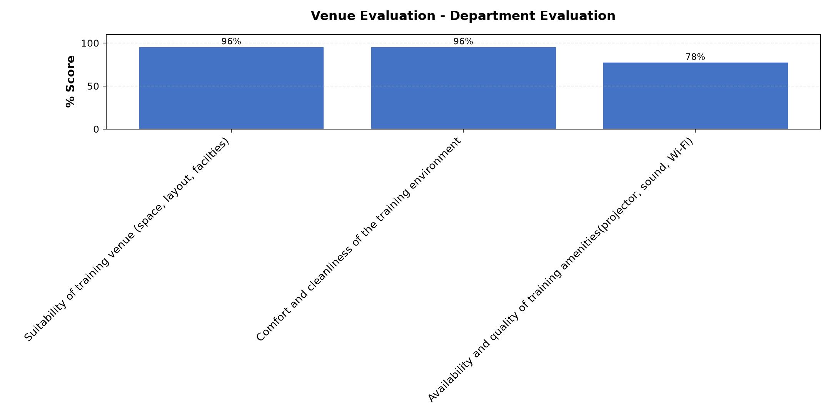

Comments & Feedback
- • Thanks for the preparations
- • WiFi needs improvement
- • Very good place
- • Good hospitality
- • A very conducive environment for learning and spiritual nourishment.
- • Wifi missed the last day

What attracted you to the programme??

Comments & Feedback
- • Committed facilitators and coordinators
- • I want to be equipped with skills to be able to grow our enterprise
- • Acquisition of skills and knowledge
- • The knowledge I get in order to improve our social enterprise
- • It was involving
- • Innovations of social enterprises in makere university.
- • The aspect of "Sisters' Blended Value Projects" and that entail therein.
- • How to make social impact in the community
- • Important of registration

What topic would you recommend being expanded/improved in this programme’s units?

Comments & Feedback
- • IT and technology,
- • All the topics were well handled
- • IT
- • IT and technology
- • Governance and succession
- • Technology the use of AI was too quick .
- • i recommend that Governance and Succession planning be expanded.
- • Governance and compliance in uganda,funding sorces
- • Registration

Which areas in this programme did you find most important to your social enterprise?

Comments & Feedback
- • All of them were relevant.
- • All the topics were very relevant in improving our social enterprise
- • Operational efficiency
- • Establishing social impact
- • Registration
- • Key aspects and procedures to follow when starting an enterprise.
- • All the areas presented very important and necessary for Social enterprises.
- • Registration of our enterprises,governance essentials,types of businesses in uganda and clarity on URA and NSSF issues
- • Taxation

Which teaching methods applied in the course did you enjoy/learn from the most?

Comments & Feedback
- • Lecturing, and sharing one by one
- • Participatory approach
- • Group work
- • Visiting social enterprise and group work
- • Discussions and practical demos
- • Presentations through discussions.
- • The participatory and discussion methods
- • Discussion method,question and answer methods.

